**“Experiment 3.1”**

**Aim:**

Interfacing Air Quality Sensor (MQ135), displays data on LCD.

**Objective:**

1. Learn about interfacing.
2. Learn about IOT programming.

**Components Required:**

1. Arduino Uno R3
2. MQ 135 AirQuality Sensor Module
3. Male to Female Jumper Wire
4. Software: Arduino IDE

**About Air Quality Sensor:**

MQ-135 sensor belongs to the MQ series that are used to detect different gasses present in the air. The MQ-135 sensor is used to detect gases such as NH3, NOx, alcohol, Benzene, smoke, CO2, etc. steel exoskeleton houses a sensing device within the gas sensor module.

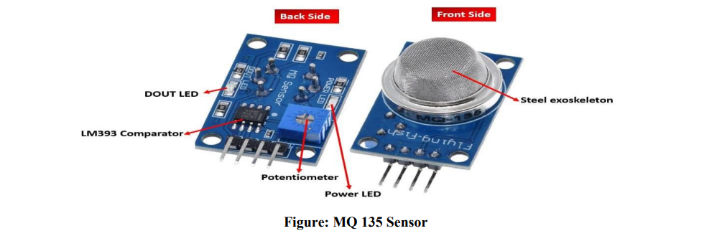

**Pin out:**

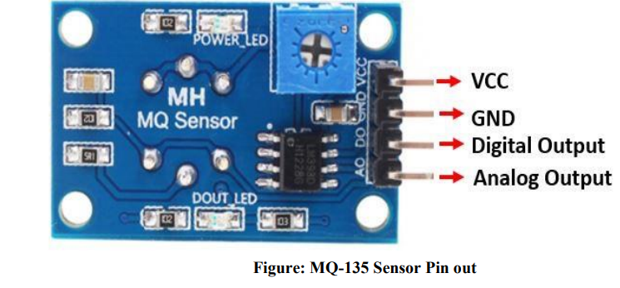

This sensor has 4 pins:

• 5V: Module power supply – 5 V

• GND: Ground

• DOUT: Digital output

• AOUT: Analog output

**Circuit:**

Interfacing MQ-135 Gas Sensor with Arduino:

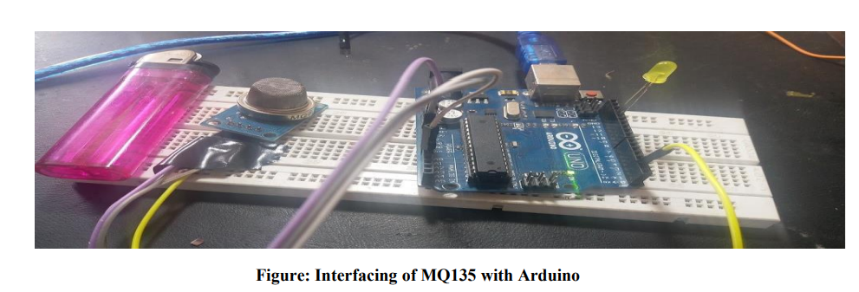

The table below shows the connections you need to make between the MQ3 sensor module and Arduino using both the analog output and the digital output pins of the sensor.

|  |  |
| --- | --- |
| **MQ-135 Module** | **Arduino** |
| VCC | 5V |
| GND | GND |
| AO | A0 |
| DO | Pin 2 |

Connect MQ-135 sensor’s VCC pin with 5V terminal of Arduino UNO. This will power up the sensor. Additionally, we will connect the analog pin AO with A0 and DO with Pin 2 of Arduino UNO. Both the devices will be commonly grounded. Follow the connection diagram below, to connect your devices accordingly.

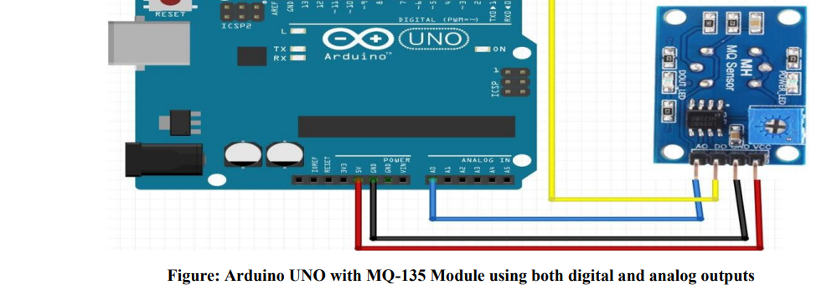

**MQ-135 Gas Detection Arduino Sketch**

Open your Arduino IDE and go to File > New. Copy the code below in that file.

This sketch will read both the analog and digital outputs of the sensor. If the analog output is greater than 400 then an LED connected at Arduino pin 2 will turn ON. Otherwise, turn the LED OFF and print both the analog and digital output readings on the serial monitor.

int sensorValue;

int digitalValue;

void setup()

{

Serial.begin(9600); // sets the serial port to 9600

pinMode(13, OUTPUT);

pinMode(2, INPUT);

}

void loop()

{

sensorValue = analogRead(0); // read analog input pin 0

digitalValue = digitalRead(2);

if (sensorValue > 400)

{

digitalWrite(13, HIGH);

}

else

digitalWrite(13, LOW);

Serial.println(sensorValue, DEC); // prints the value read

Serial.println(digitalValue, DEC);

delay(1000); // wait 100ms for next reading

}

}

**How the Code Works**

Create two int variables to hold the analog and digital output readings.

int sensorValue;

int digitalValue;

Inside the setup() function, we will open the serial communication at a baud rate of 9600. Then configure pin2 connected with the DO pin of the sensor as an input and pin13 connected with the LED’s anode pin as an output.

void setup()

{

Serial.begin(9600); // sets the serial port to 9600

pinMode(13, OUTPUT);

pinMode(2, INPUT);

}

In the infinite loop(), we will use analogRead() on the A0 pin and save the value in ‘sensorValue.’ Likewise, we will read the digital output on pin2 using digitalRead() and save the value in ‘digitalValue.’ Next, using an if-else statement we will check if the analog reading is greater than 400 or not. If it is then turn the LED ON. Otherwise, leave the LED OFF and display the current analog and digital readings in the serial monitor.

void loop()

{

sensorValue = analogRead(0); // read analog input pin 0

digitalValue = digitalRead(2);

if (sensorValue > 400)

{

digitalWrite(13, HIGH);

}

else digitalWrite(13, LOW);

Serial.println(sensorValue, DEC); // prints the value read

Serial.println(digitalValue, DEC);

delay(1000); // wait 100ms for next reading

}

**Demonstration**

To see the demonstration of the above code, upload the code to Arduino. But, before uploading code, make sure to select the Arduino board from Tools > Board and also select the correct COM port to which the Arduino board is connected from Tools > Port.

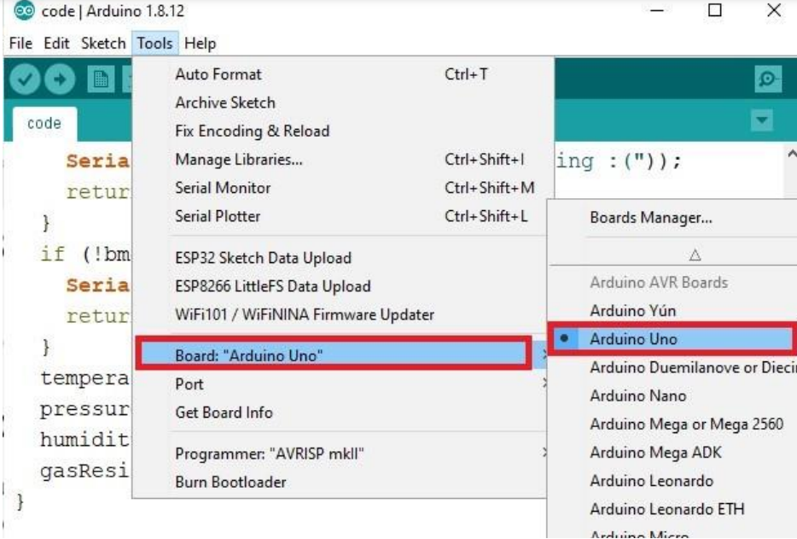

On the serial monitor, you can see the values of the analog pin being detected. Currently, in my case, they are around about 150, which indicates normal air.

• Normal air returns approximately 100-150

• Alcohol returns approximately 700

• Lighter gas returns approximately 750